EXAM-2  
Distributed Networks

Bhavesh Naidu Kulluru

717541

Limitations: None   
  
  
Outputs :   
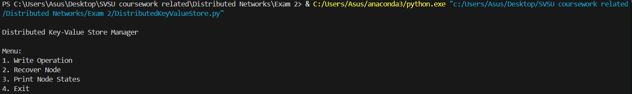  
  
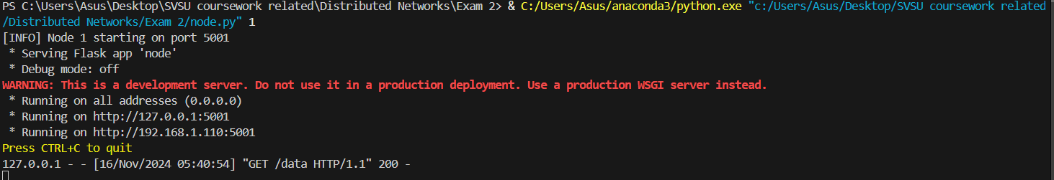

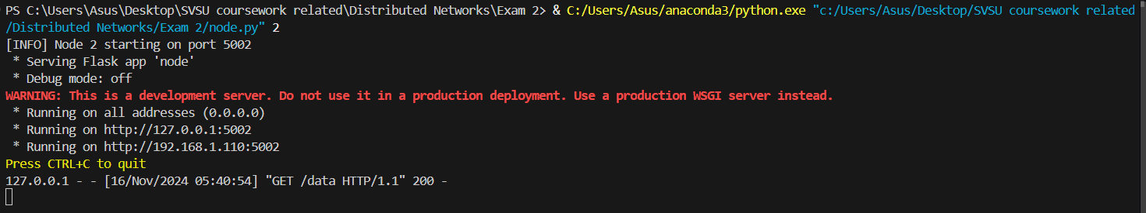

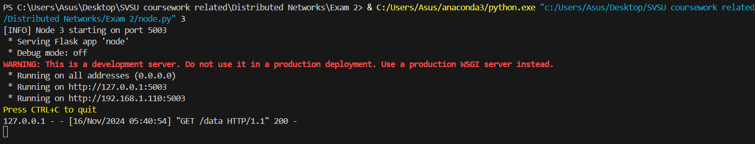

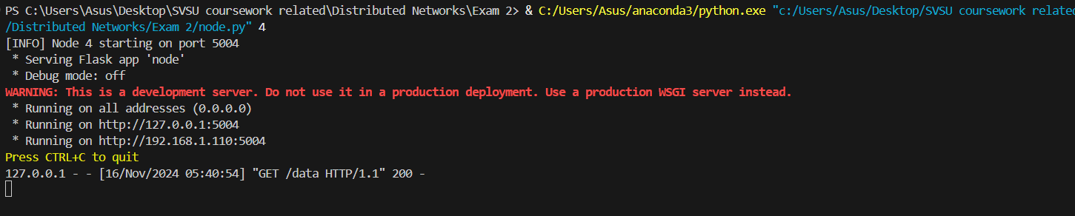

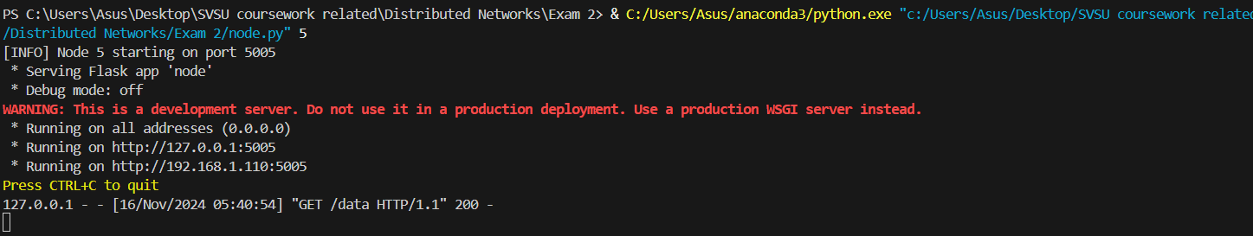  
  
Initial Node states :   
  
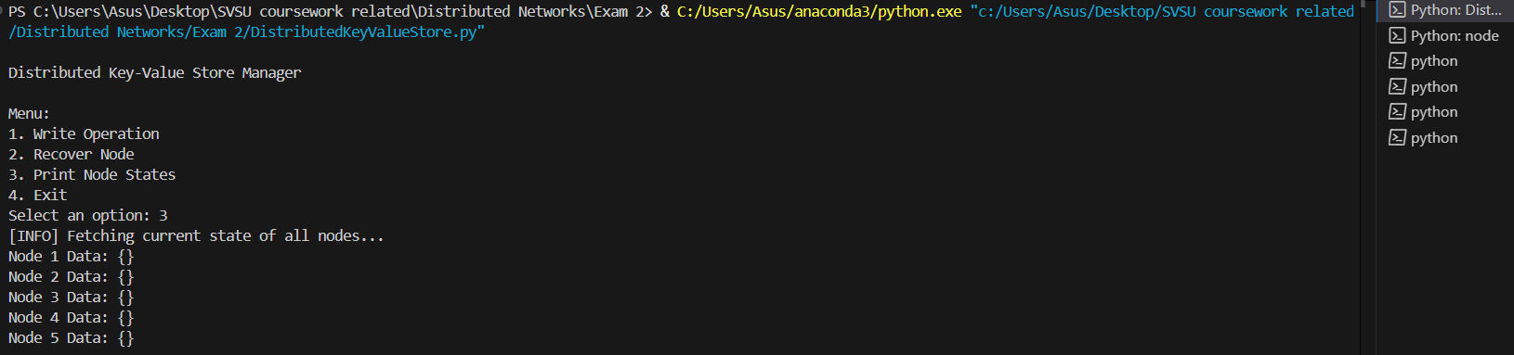

Write to nodes:  
  
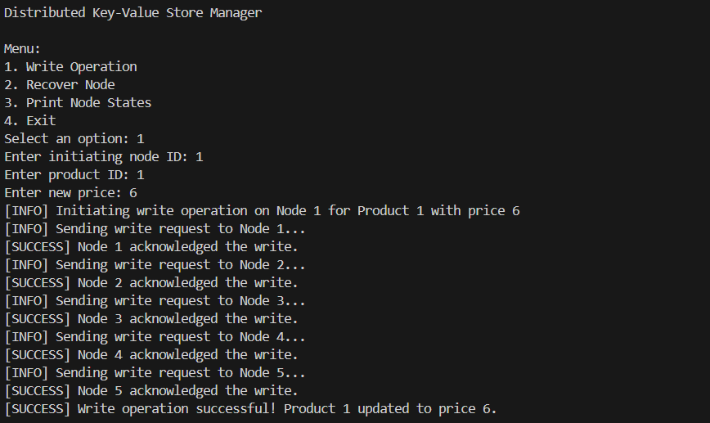

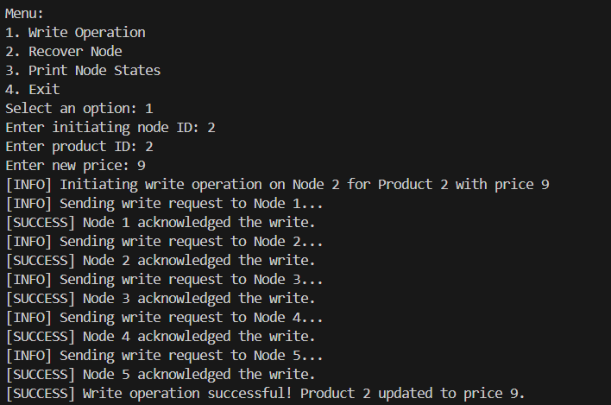

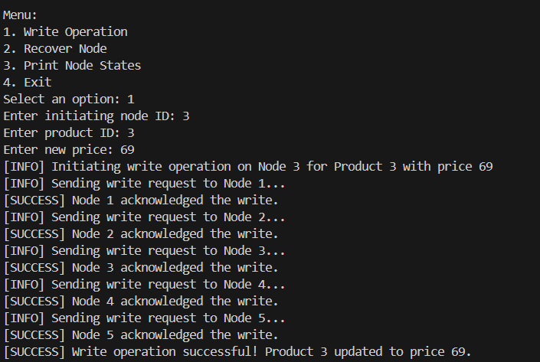

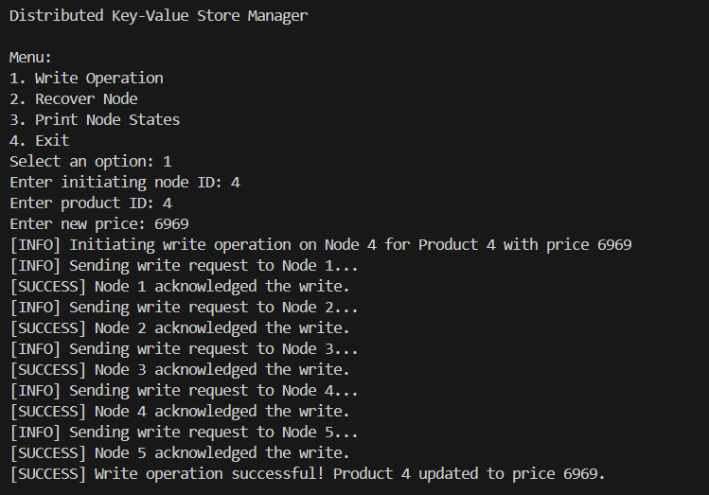

Printing Current Node States:

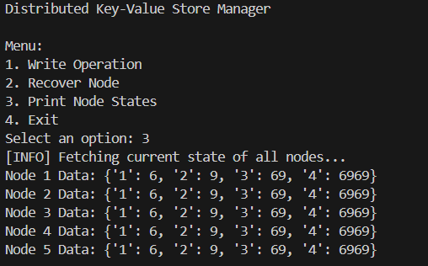

REMOVING NODE 4

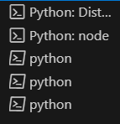

PRINTING VALUES WITHOUT NODE 4  
  
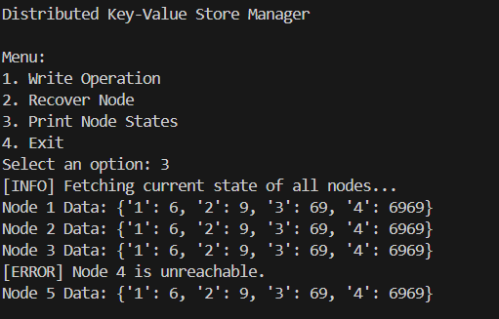

MAKING CHANGES WITHOUT NODE 4

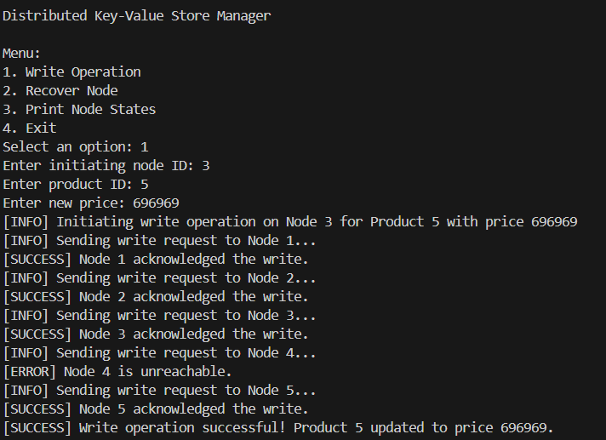  
  
CURRENT STATE:  
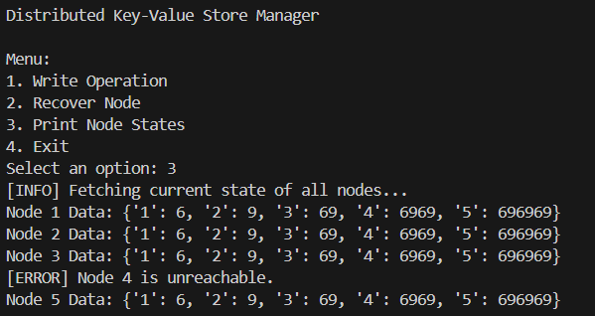  
  
  
BRINGING NODE 4 ONLINE

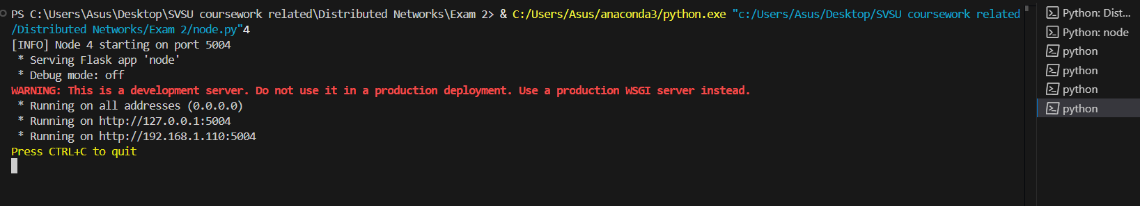

STATE BEFORE RECOVERY :

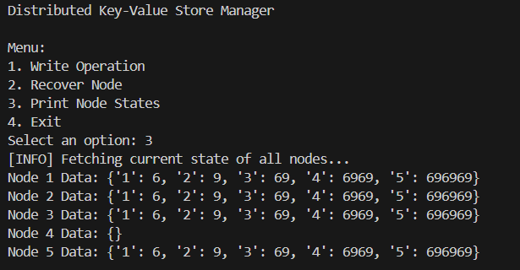

RECOVERY :   
  
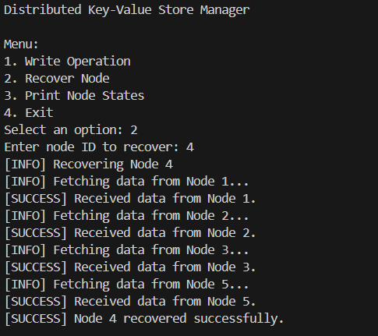  
  
STATES AFTER RECOVERY :

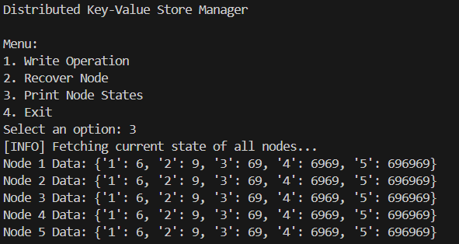

THANK YOU